Jonah Taylor 8:07 AM

joined #reptile-mister-2 along with 2 others.

Jonah Taylor 10:58 AM

Researched diaphragm vs centrifugal pumps and ordered supplies - buying both a centrifugal and diaphragm pump for now, will return the unused one later. Looked into costs of 3D printing device enclosure, brainstormed designs (edited)

Jonah Taylor 10:06 PM

Centrifugal pump arrived today - it's not gonna give enough pressure for what we need, so ordering an AC adapter + some tubing adapters that I'll need to get to test the diaphragm pump (was hoping to avoid that one - noise will be a much greater factor, might need to make a separate enclosure for the pump)

liu 9:02 AM

time to add technical contents

Jonah Taylor 9:28 AM

Centrifugal pump is rated for 550 gallons p/hour (GPH), but doesn't have a pressure rating, so needed to test manually. Benefits were quiet operation and submersible, allowing us to place it directly in the reservoir w/out needing extra tubing. After testing with misting equipment, pressure was far too low to get any good mist out of the sprayers.

Diaphragm pump is rated up to 80 psi, so should get us much more pressure. Only rated for 1 GPM of flow, but that shouldn't be an issue for our application. Risk: pressure rating may be too high for the misting hardware, so may need to test systems to reduce pressure (one option: add an outlet line back to the main reservoir). Main issue with diaphragm pump is operating noise - I can measure it quantitively later, but it operates much more loudly than the centrifugal pump. It is not submersible, so extra tubing/adapters will be required, and the enclosure for the system will need a way to leave it exposed for maintenance while protecting the electronics from possible leakage.

Current status: waiting for 3/8 ID tubing and a 3/8" -> 3/4" threaded adapter to hook up to misting hardware. Pump requires 3/8" tubing, misting system requires 3/4" male threaded connector. Once those arrive, I can test whether the diaphragm pump will work for our purpose (edited)

liu 11:57 AM

checked again --

Jonah Taylor 12:33 PM

renamed the channel from “reptile-mister” to “reptile-mister-2”

Osric Nagle 8:10 AM

still waiting on parts over on this end, unfortunately

Osric Nagle 8:36 AM

breakout room: 36

Pinned by you

Jonah Taylor 8:44 AM

Task tracking board: https://trello.com/b/VB7Ketgy/csce-462-project

liu 8:48 AM

did not see your board from the link above.

1 reply

5 days agoView thread

Osric Nagle 9:18 AM

Initial hardware setup/testing video:

MPEG 4 Video

JonahOsricInitialHardwareTesting.mp4

17 MB MPEG 4 VideoClick to view details

Jonah Taylor 7:44 PM

Tested putting silicone sealant on the fittings, but it did not fix the leaking issue. The pump connections are plastic, which makes over-tightening the fittings a dangerous risk. Will brainstorm other ways to fix the problem, may need to buy tubing in a smaller size or look for a pump with lower pressure rating.

Another possible fix could be to attach a pressure regulator to the end of the system (after all of the misting nozzles). This would allow us to lower the pressure on the pump connector, but raises issues of compatibility since the misting tubing is very narrow. It would require a specialized adapter to step up to a more standard tubing size (edited)

New

Osric Nagle 10:06 PM

Received humidity and float sensor. Researched more about each one to figure out how to connect them to the raspberry pi. Connected the humidity sensor to the raspberry pi. Have not yet been able to read data from the device.

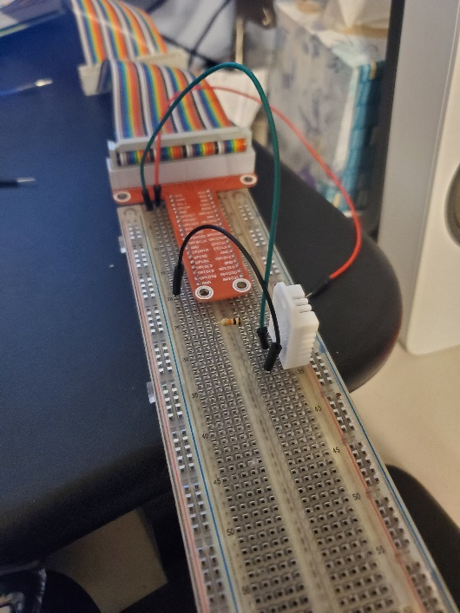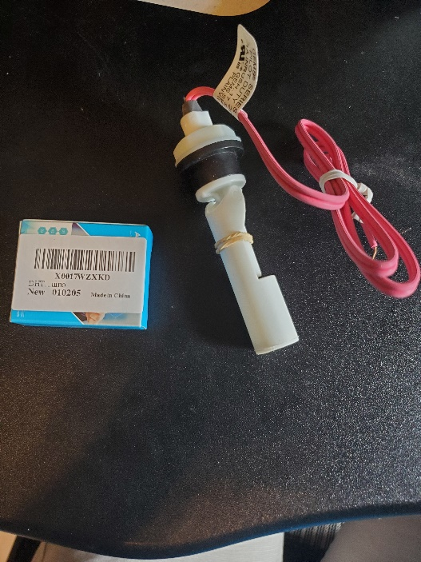

10:08

Resource for learning/using DHT22 humidity sensor: https://learn.adafruit.com/dht

liu 10:38 PM

checked

Both of us have updated the trello board with the full range of tasks required for our project, including expected due dates.

8:52

New link to python specific DHT11 sensor library: https://github.com/ikornaselur/pico-dht11 (not sure if this will work with DHT22 as we have, will try it out)

GitHubGitHub

ikornaselur/pico-dht11

Contribute to ikornaselur/pico-dht11 development by creating an account on GitHub.

Jonah Taylor 9:59 PM

Found the DHT22 python libraries and tested its output - it can gather data about once per second, which is fast enough for our use. Will need more testing and comparing with my other humidity sensor to tell its accuracy, but it responds well to changes in humidity. Tested it by gathering data in a loop and breathing on the sensor to raise humidity - sensor responded as expected

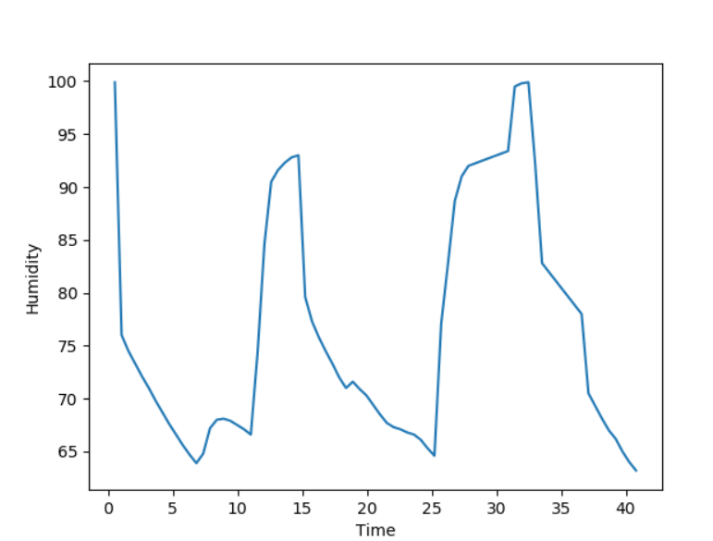

Osric Nagle 10:04 PM

On my end, I was also trying to get the humidity sensor to work, but unfortunately, I burned the sensor out without realizing. Exact cause of burnout is uncertain, although most likely some incorrect wiring was to blame.

10:05

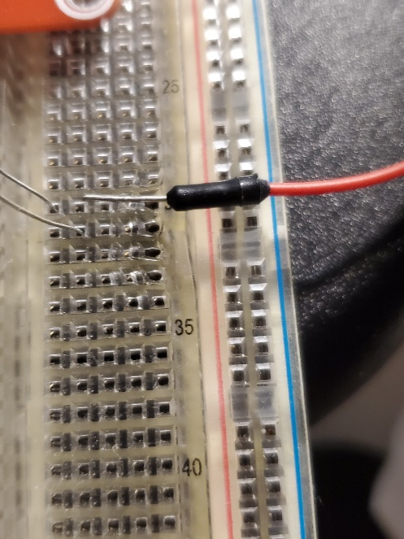

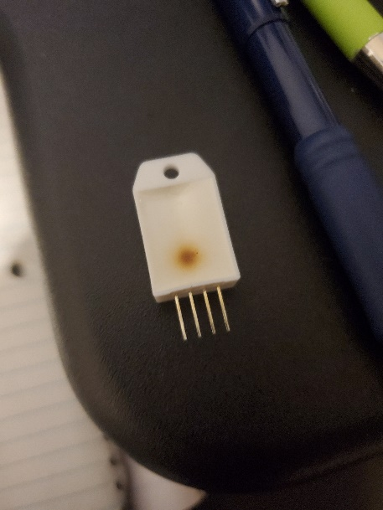

Jonah Taylor 12:55 PM

Cut/assembled the final layout for the tubing, and attached it to the lid of the vivarium. Fixed the leaking issues between the pump and tubing. Pressure is holding up well on the 4 spraying nozzles, no signs of leakage on the new tubing so far

3 files

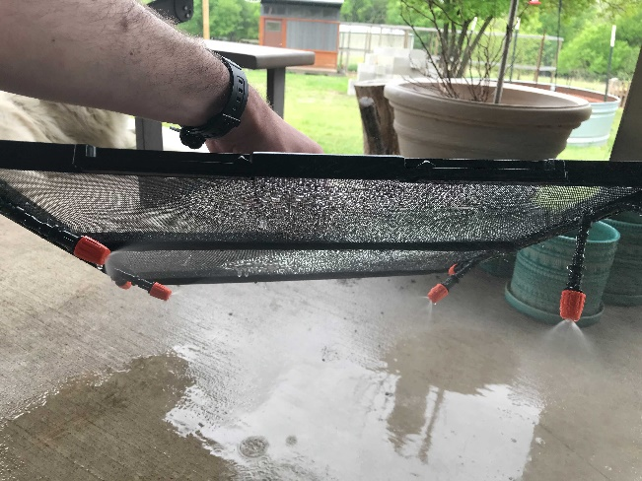

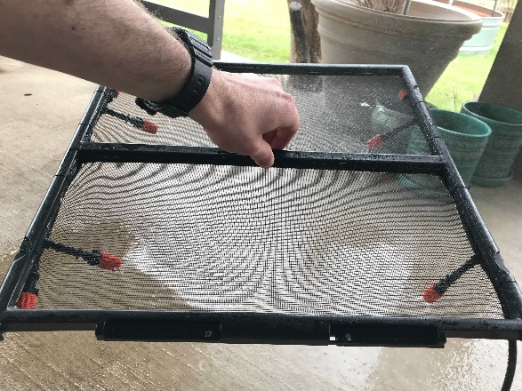

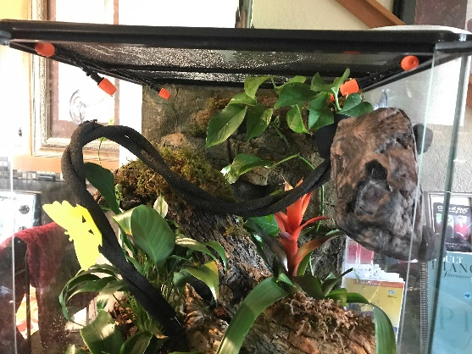

Osric Nagle 9:24 PM

Got the level switch to work with a primitive setup. In order for this switch to work with our system, we will either need to have the level switch submerged, or attach substantial flotation devices to it that will keep it above the water level.

9:25

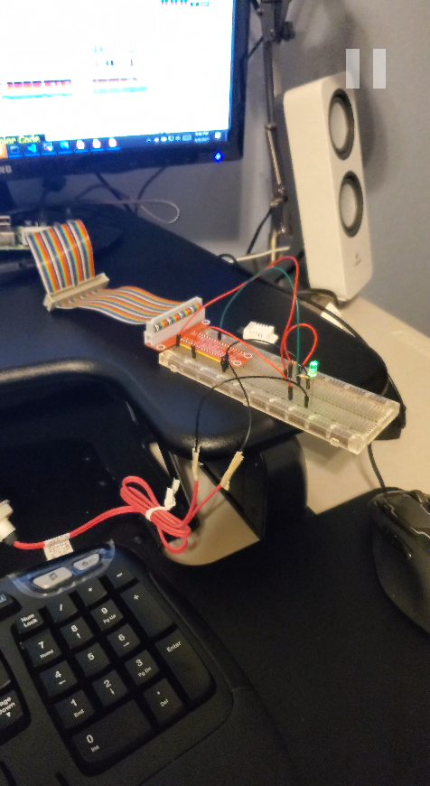

Jonah Taylor 1:22 PM

Relay module is set up. Made a separate python file for handling just the pump control, so that we can do error checking (using the level sensor) inside of a separate file. Also added a button switch that can manually override the pump's state using interrupts. We can use this button for testing, or as a kill switch for safety. Connections for getting this setup are documented in the python file

Just hooked up to an LED for testing currently, but next steps is to splice this into the DC power wires for the pump itself. Will probably wait until the enclosure is built to connect that all up, though (edited)

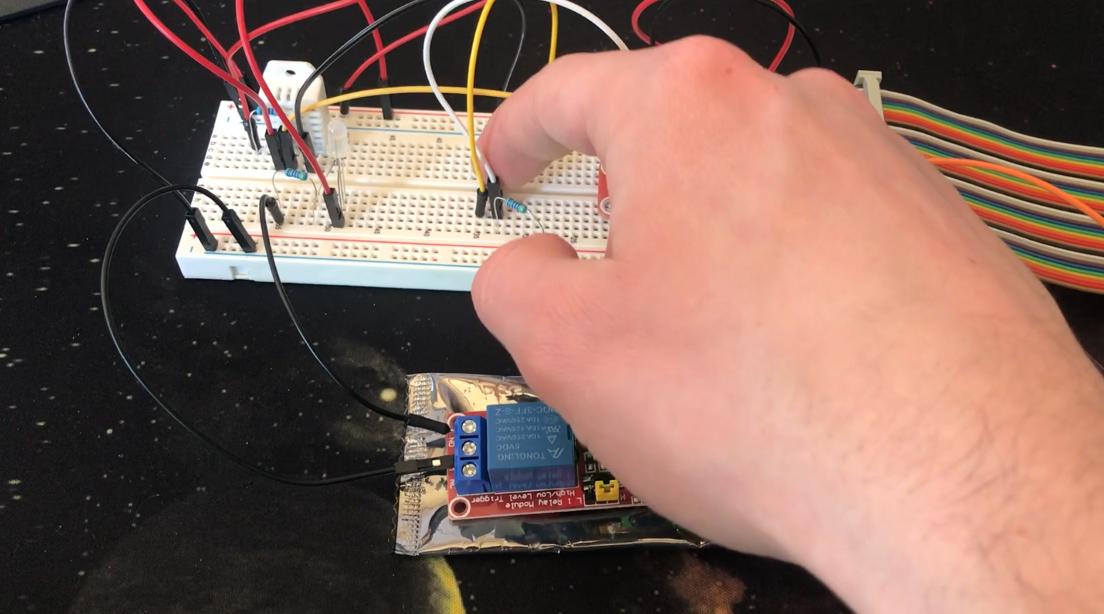

liu 7:33 AM

CKPT 1: good progress. Are you a 3-person team or 2? Osric, pls add your own (head shot) picture

Jonah Taylor 11:56 AM

progress update: I made structure of the enclosure box, don't have any wire/tubing holes drilled in it yet, though. Original plan was to have 2 parts, with the top one being a cover that goes over the electronics (see picture 3). The pump will be mounted to the underside of the bottom box, and the electronics will be mounted to the top side of the bottom box. This will isolate the pump from the electronics in case of leakage, and make sure the pump is easily accessible for maintenance. After seeing it in person, I may decide to skip the top section and leave the electronics open. This will greatly reduce the enclosure's size, but might not look good

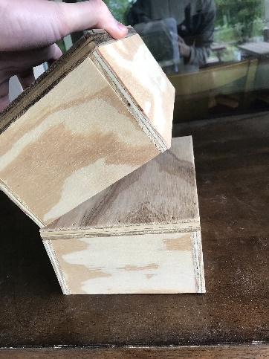

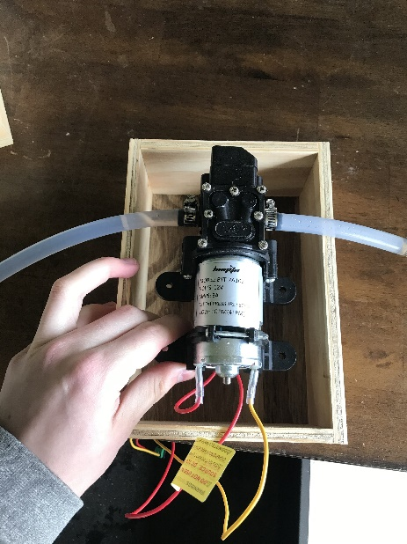

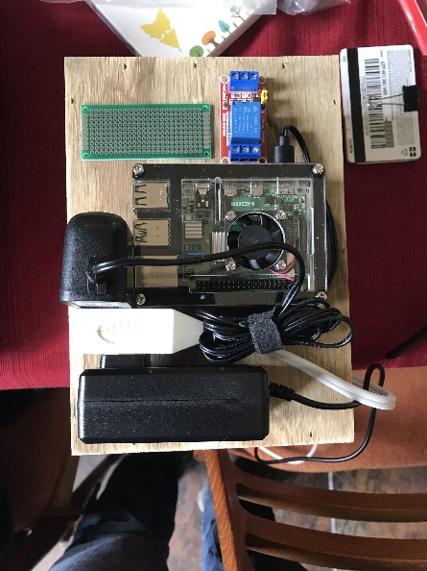

11:57

next steps are to drill holes in the box for the tubing/wires, then solder all of the major components onto the prototype board